Keeping Cool
Your task is to build a model house that stays as cool as possible in Broome’s hot climate using only the materials listed below and within a tight budget. Your house must contain a clear, open space of 30cm x 20cm x 20cm within it.

- You get (for free) 1 A4 sized box, glue, scissors and sticky tape.
- You get to purchase (with a budget of $3000 worth) the following:
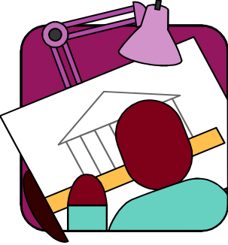
- A3 sheets of alfoil: @ $500 each
- 1 Coat of paint @ $500 each
- A3 sheets of white paper: @ $200 each
- Sheets of newspaper: @ $100 each
- A4 sheet of polystyrene: @ $1000 each
- A4 sheet of cardboard: @ $500 each
- Popsticks: @ $10 each

- Keep a track of your purchases from “Science Building Supplies Inc.” in the table below:

Material | Cost per Unit ($) | No of Units | Cost of Order ($) | Total costs to date ($) | Authorised by:

Things you need to do after building:
You need to test your house in direct sunlight for 20 minutes to show temperatures inside over that time. Record and show these results and include a detailed explanation of the design features you included in your house that you think will keep it cool.

